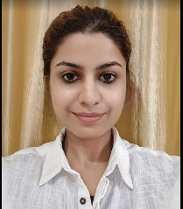 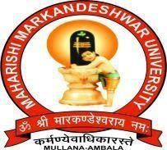

M. M. Engineering College (MMEC)

MAHARISHI MARKANDESHWAR DEEMED TO BE A UNIVERSITY

**NAME :** Subah Kumar

**Email :** [su](mailto:shubh11162538@gmail.com)[baharora45@gmail.com](mailto:baharora45@gmail.com)

**Contact no :** 8307804819, 9034004819

**Career Objective**

I am seeking a company where I can use my experience and education to help company meet and surpass its goals.

|  |  |  |  |  |
| --- | --- | --- | --- | --- |
| **Qualification** | | | | |
| **Year** | **Course** | **Institute/College** | **University/Board** | **Marks** |
| 2021 | B-Tech (CSE) | M.M.E.C | M.M.D.U. | 9.08 |
| 2017 | Diploma | Seth Jai Parkash Polytechnic, Damla | HSBTE- Haryana  State Board of Technical Education. | 81% |
| 2014 | X | Dav public school | C.B.S.E | 8 CGPA |

|  |  |  |  |
| --- | --- | --- | --- |
| **Experience** | | | |
| **Start Month & Year** |  |  | **Company/Institution Name, Location** |
| **Duration** | **Project Description** |
| September 2021-currently ( 2023) | 1 year 8 months | Multiple projects | Ericsson, Noida |
| 2017 -2018 | 1 year | Intern | Wipro Limited, Gurugram |

**Extra – Curricular Activities**

* Member of Training and Placement Cell Society which organizes all the placements that take place at the University.
* Received 1 year of government training certificate in Wipro as well as from Wipro Limited.
* Participated in various sports competitions, quizzes, and debates during my Diploma.
* Coordinator in UNIVERSUM 2k18 held in the college.
* Attended 2 days National Workshop on mobile and Web Application Development.
* Achievements in Academic in Diploma as well as Btech.

**Technical Skills**

1. Technical Skills : Html,CSS,JS,DOM,Jquery,Node.js,API,React.js
2. Database : SQL,MongoDB

**Interests/Hobbies**

* Listening to music and singing helps me with Stress Management.
* Doing exercise on a regular basis.

**Strengths**

* Joint management.
* Determination towards my duties.

**Personal Information**

Father’s Name : Mr. Gopal Inder Kumar

Date of Birth : 09.01.1997

Nationality : Indian

I hereby declare that the above-written particulars are true and correct to the best of my knowledge and belief.

**Date:** 2023 Subah Kumar

**Place:** Yamuna Nagar **Signature**